**Project – I Report**

**House Price Prediction**

**Subject Code: - 4IT31**

**Group Number: - G13**

**18IT404: Man Desai**

**18IT405: Kalp Gohil**

**18IT413: Param Shah**

**17IT419: Jay Patel**

**Guided By :- Prof. Prachi Shah**

**BACHELOR OF ENGINEERING**

***In***

**INFORMATION TECHNOLOGY**



**Birla Vishvakarma Mahavidyalaya**

**Engineering College,**

**Vallabh Vidhyanagar-388120**

* **Motivation**

There are lots of people making huge mistakes when buying the properties. Most of the people are buying properties from the people they do not know or by seeing the advertisements. One of the common mistakes is buying the properties that are too expensive but it is not worth it. And at the end people sum up with loss.

So our main motive here is to build a model that will help people who want to buy or sell any properties. It will help people by predicting nearest price of a house according to parameters of that house. So it will help society and also reduce human effort and at the end people will sum up with happiness.

* **Main Purpose of Our Project**

The goal to predict the price of a given house according to the market prices taking into account different “features” that will be developed in the following sections.

Main objective in this project is to obtain reasonably good to predict house prices based on some variables included in the dataset.

* **Modules**

1. **Selecting Dataset.**
   * One csv file that contains information about price of a house according to some parameters.
2. **Data Processing.**
   * After having data in hand, it’s important to pre-process the data to transform raw data in a useful and efficient format.
   * **Data Cleaning:** Dataset can have many irrelevant data and missing parts. So it is required to clean data.
     + Dropping Null values.
     + Filling Null values with mean.
3. **Data Transformation.**
   * After data cleaning, need to transform data into appropriate form suitable for model training.
   * **Attribute Selection:** In this strategy, new attributes are constructed from given set of attributes to help model.
     + Aggregate function can be used on two or more columns to have new column that may have highly positive or highly negative correlation with target value.

1. **Selecting Model.**
   * Now data is all set to be trained. But How….??
   * So, it is required to select an appropriate training method to train model.
   * So, understanding relationship between various set of attributes using histograms, pie charts, bar graphs, etc can help one to select best method to train model.
2. **Display the result.**
   * One simple website has been created to deploy this model, that takes input as parameters and predict house price accordingly.
   * Django framework is used for same.

* **Requirements**
* Python Language
* Numpy library
* Pandas library
* Matplotlib library
* Basic of Scikit-Learn library
* Django Framework
* **SRS Diagrams**
* **Data Flow Diagram**

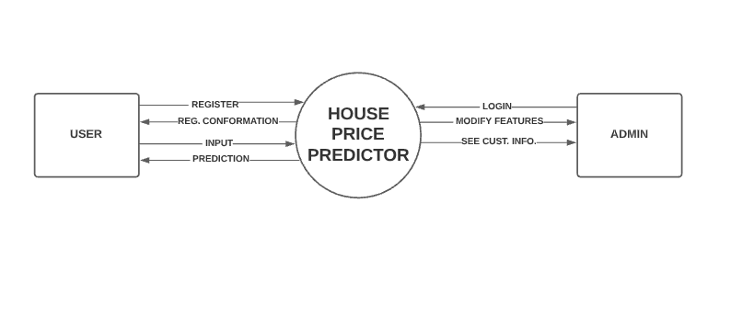

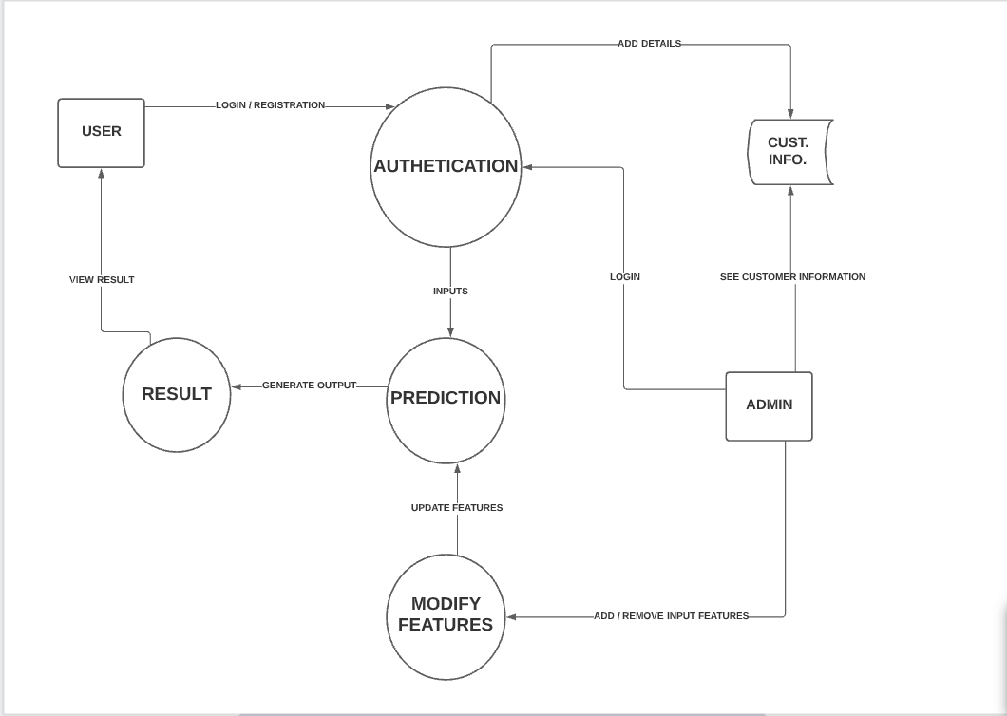

* **Use Case Diagram**

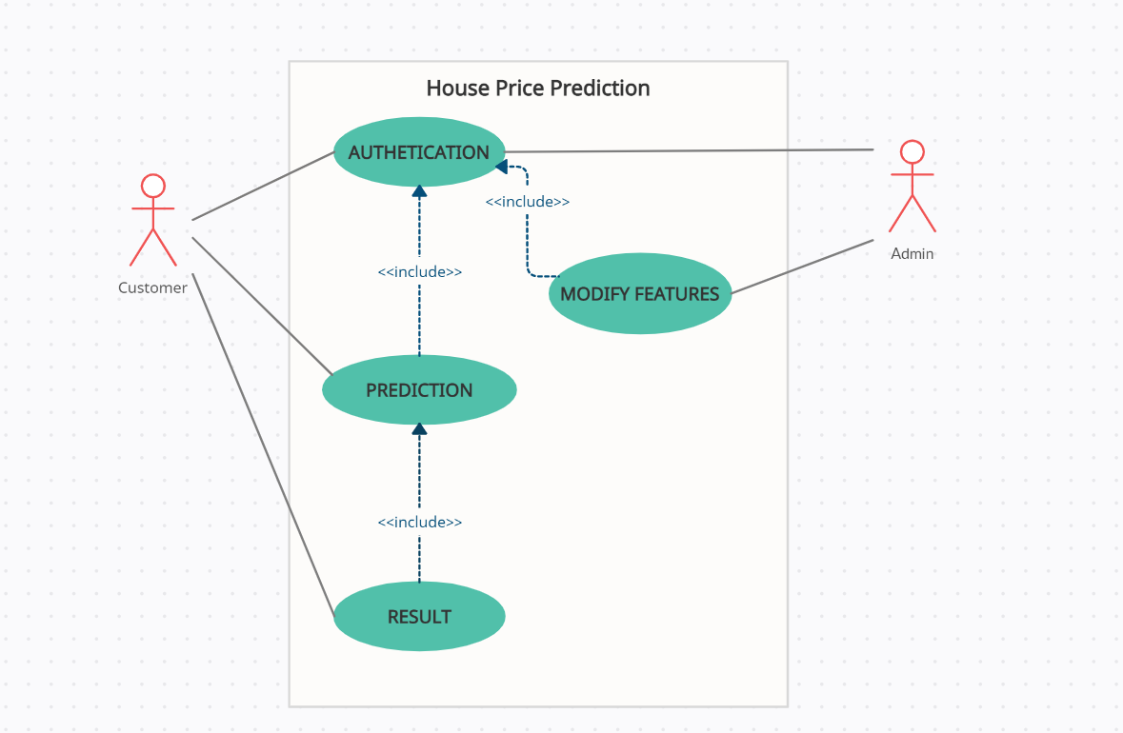

* **Sequence Diagram**

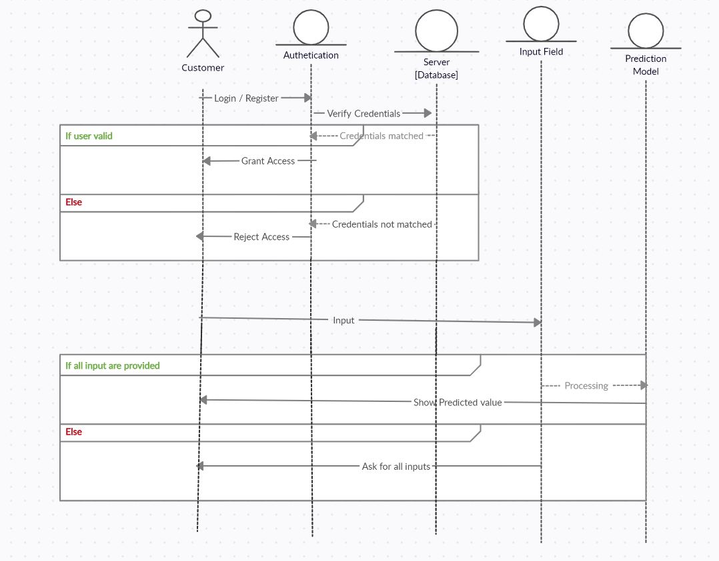

* **Model View**

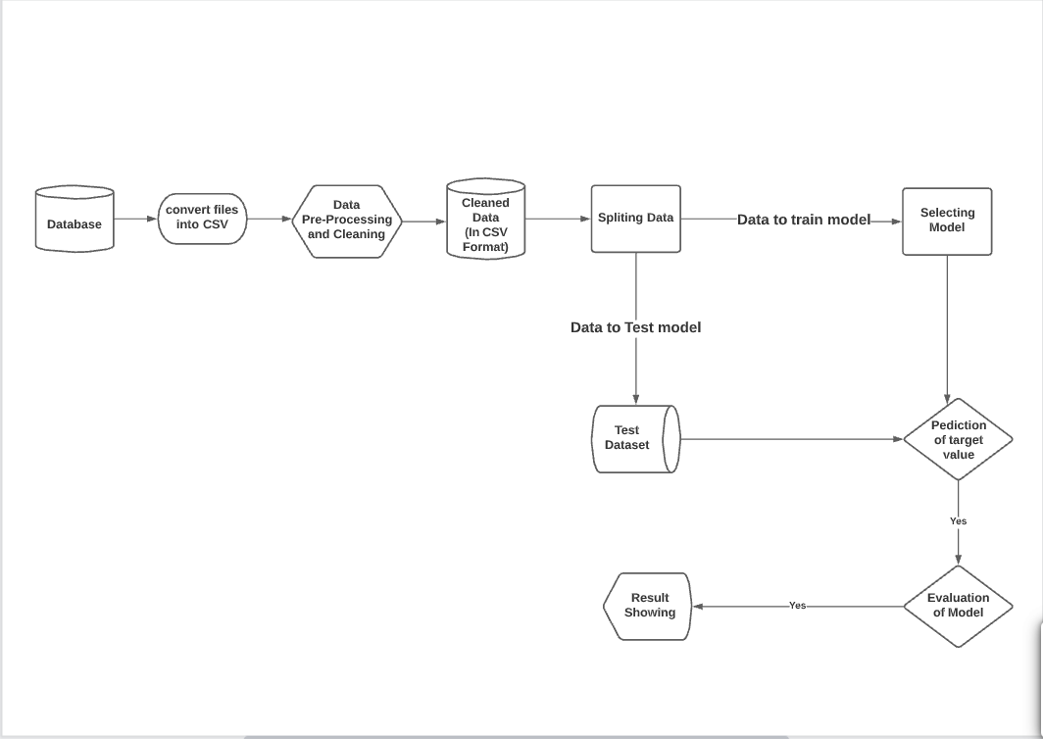

**Lab - 01**

Date: - 09/08/2021

Time: - 14:00

* **Discussion Topics**
* Project Report
  + Modules
  + SRS Diagrams
* **Suggestions By Guide**
* Change Words like I, we, our…
* Change Symbols of Cust. Info. in DFD-01.
* Change in Model View.
* **Agenda of Next Lab**
* Project Report
  + Hardware & Software Requirements.
* Implementation
  + Selecting Dataset
  + Getting initial statistical information from Data.